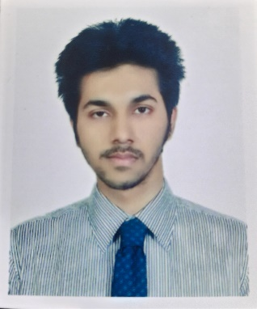**Curriculum Vitae**

Name: **Sk Md Abuzar Gifari**

Cell: +8801783753653

Email: [shaikh35-3024@diu.edu.bd](mailto:shaikh35-3024@diu.edu.bd)

LinkedIn: <https://www.linkedin.com/in/sk-md-abuzar-gifari-649a80203/>

GitHub: <https://github.com/abuzar-gifari>

Portfolio: <https://abuzar-gifari.github.io/portfolio/index.html>

**Career Objective:**

Highly self-motivated Software Graduate skilled in web design and development tools with proven communication and teamwork skills. I am seeking to join Aiva Labs Inc as a Laravel developer to utilize my knowledge and skills to help the company through web development and branding for generating revenue.

**Relevant Skills & Projects:**

|  |
| --- |
| Core Competencies Projects on GitHub |
| • **Programming Languages:** PHP, • Ecommerce Project, Laravel  JAVA, JavaScript, Python. • Restaurant Management System, Laravel  • **Framework:** Laravel, Vue.js • Hospital Management System, Laravel  • **Library:** jQuery • Bazar Project, Vue.js  • **Programming Platform:** PhpStorm, • Full Ecommerce Project, PHP-v07  Visual Studio Code, Intellij IDEA • Book List App, JavaScript  • **Tools:** MSOffice • Pioneer Bank Project, JavaScript  • **Experienced with Git & GitHub** • School Management System, Laravel |

**Interpersonal Skills:**

• Able to handle pressure and positively motivate people.

• Able to make friends quickly and get along with others.

• Showing Empathy and Understanding.

• Being a Clear Communicator.

• Negotiation Skills.

• Behaving Appropriately.

**Educational Background:**

• **B.Sc. in Software Engineering**

Institution: Daffodil International University.

Course Completion: 2022

CGPA: on a scale of 4.00

• **Higher Secondary Certificate (HSC)**

Institution: Shaheed Police Smrity College, Dhaka.

Year of Passing: 2019.

Board: Dhaka

GPA: 4.08 on a scale of 5.00

• **Secondary School Certificate (SSC)**

Institution: Adamzee Cantonment Public School, Dhaka.

Year of passing 2017

Board: Dhaka.

GPA: 5.00 on a scale of 5.00

**Personal Information:**

Full Name : Sk Md Abuzar Gifari

Father’s Name : Sk Md Shahidul Islam

Mother’s Name : Meherun Nesa

Date of Birth : 18 September, 2000

Marital Status : Unmarried

National Id No : 6915194861

Religion : Islam

Present Address : Mirpur-13, Road no-8, Block-C, Dhaka

Permanent Address : Barshibaria, District-Meherpur, Khulna-7100

**Awards and Certificates:**

• PHP & Laravel full-stack course from HR Ventures – Jan-10-2022

• The Complete Front-End Web Development Course! (Udemy) – Sep-06-2020

• Python Crash Course for Beginners (Udemy) – Jan-23-2022

• Bootstrap and jQuery Certification Course for Beginners (Udemy) – Jan-24-2022

• JavaScript, Bootstrap, & PHP - Certification for Beginners (Udemy) – Jan-26-2022